**Description**

**I/Home page:**

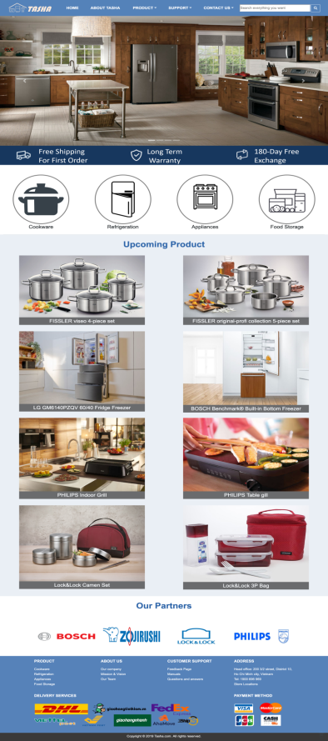

Home page shows Logo of Tasha company, navigation , slideshow of some special products, information about shipping/warranty promotion, some upcoming products and our brands

To be more, Footer also shows shortcut to other sites, shipping and payment method for customer.

Logo of Tasha company includes symbol of kitchen appliances under one roof and company name. It means where there’s Tasha’s products, there’s home.



Navigation bar includes links to **Homepage**, **about company**, **products** (which is divided by brands and by categories), **support** (link to feedback page, manuals, Q&As), **contact** ( head office and store locations) and searchbar



After that, the main impression of the page is the slideshow of some special products, additionally under slideshow is some highlighs about company policies on shipping, warranty and exchange. Under, there are logos of four product categories

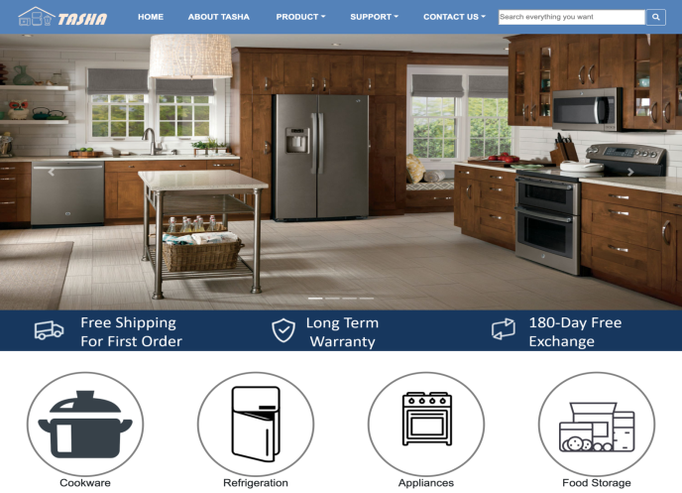

Then we show upcoming products and our partner brands

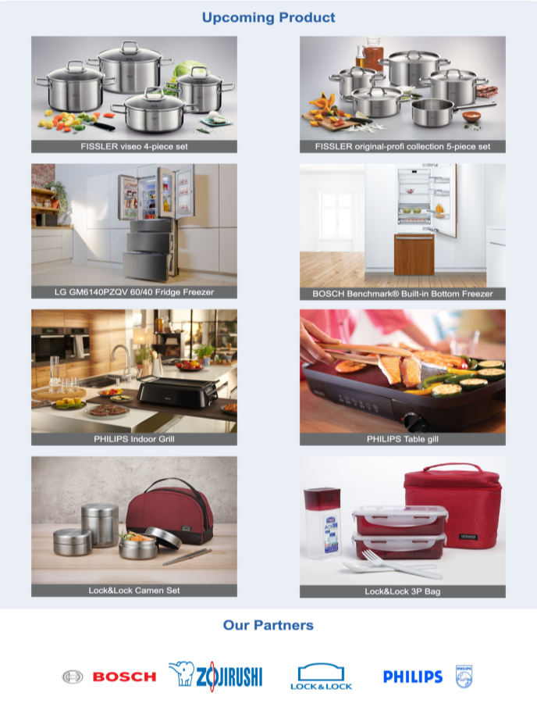

The footer is an important part,

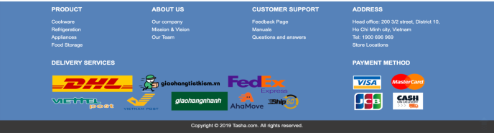

**II/ Cookware, Refrigeration, Apliances, Food Storage pages:**

Includes introduction and product collection

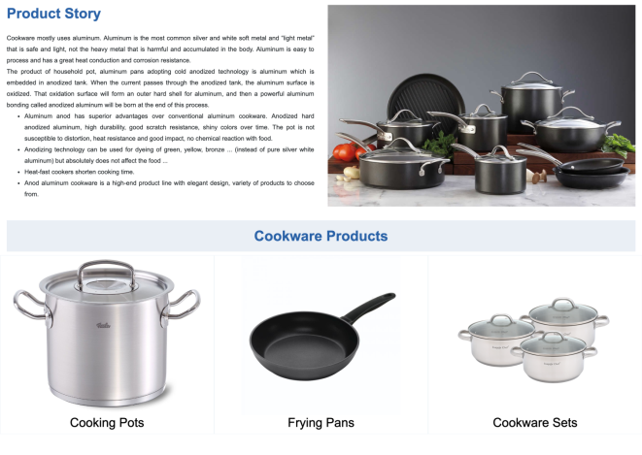

**III/ Categories product**

Picture categories product and high light of product in company

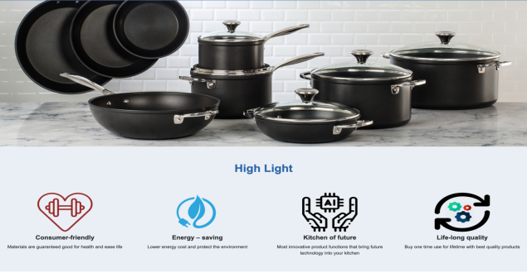

Each image get directive link to the detail page of that product if user want to see more infor about it.

List menu can support user find product of brand or all categories product easy

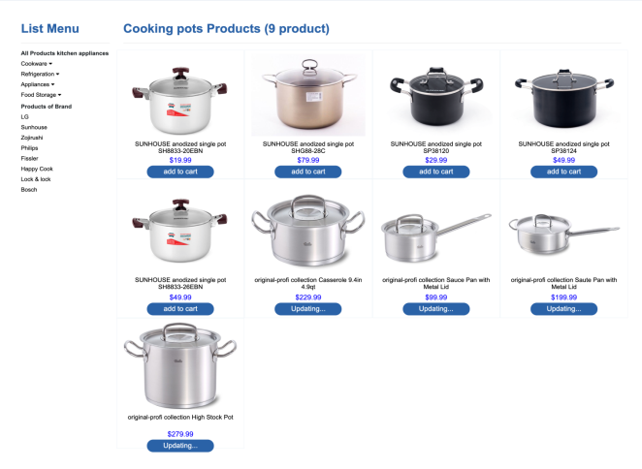

**IV/ Product of brand:**

Information introduction of brand

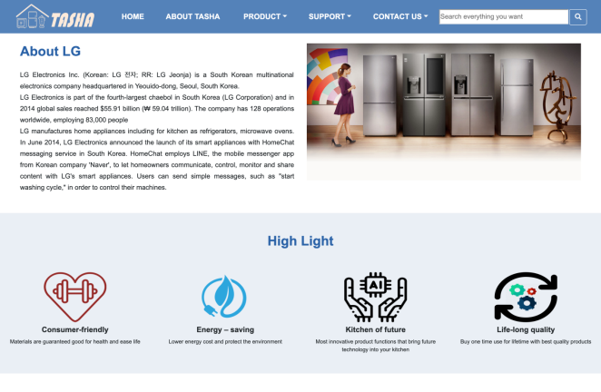

All products of one brand

Each image get directive link to the detail page of that product if user want to see more infor about it.

List menu can support user find product of brand or all categories product easy

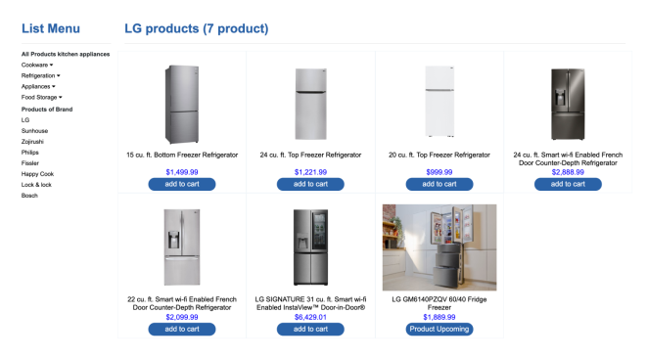

**V/ Detail pages:**

Detail page shows full information about product users are interested in.

Slideshow pictures of product and users can hover the image to see clearly the product.

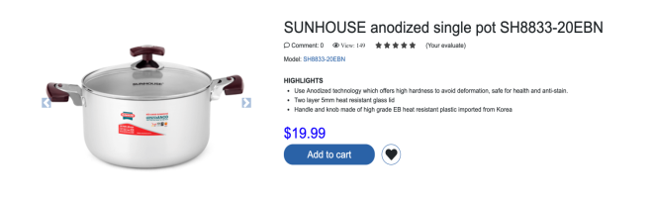

Product detail and specification of product.

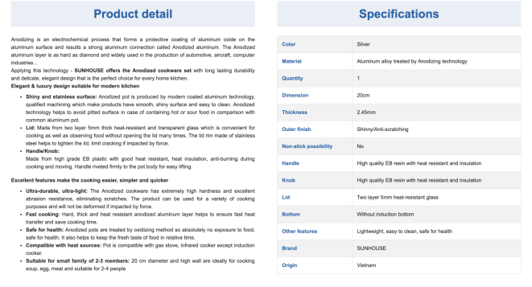

Slideshow products same category.

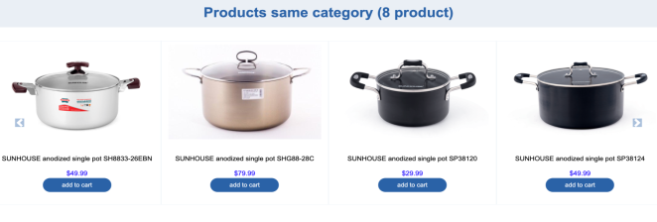

**VI/ Head office page:**

Showing the Address of Tasha company’s Headquarters, representing by google map

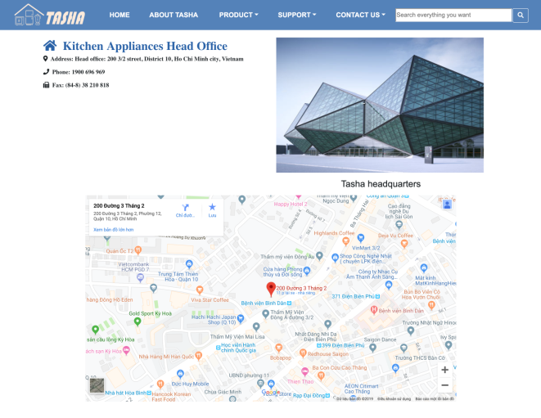

**VII/ Sale Locations page:**

List of Branches of Tasha, users can click on the list to find the office nearest to them:

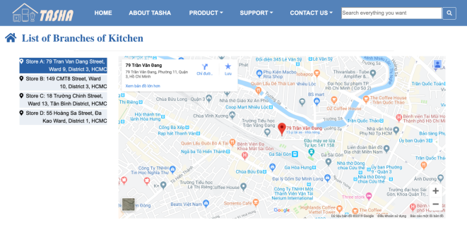

**VIII/ Feedback page**

Drawing a form where users could leave their feedback or questions about Tasha products

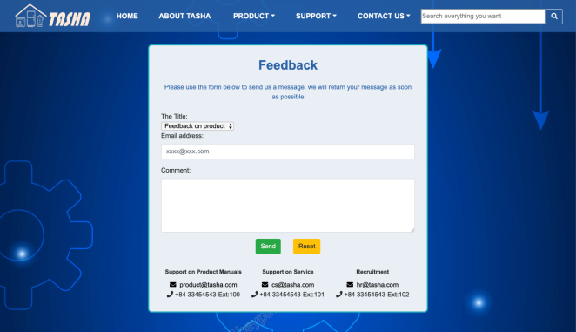

**IX/ Question and Answers**

Users can see some common questions and answers, giving questions to the company

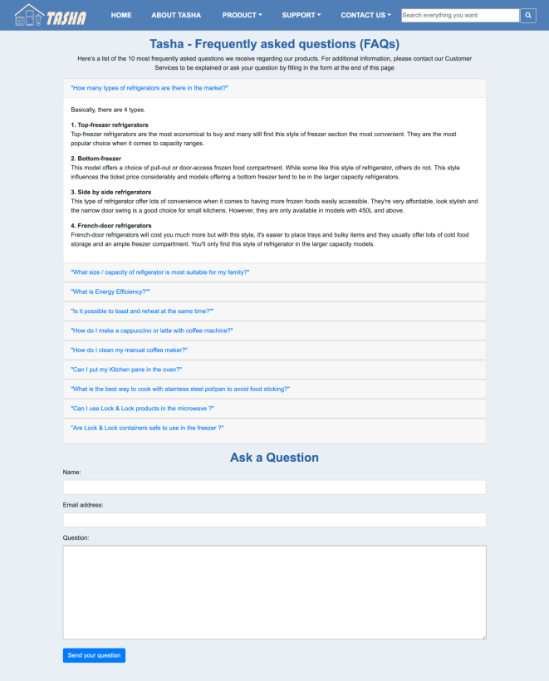

**X/ Manuals**

Users can download word filds to view the product's user guide

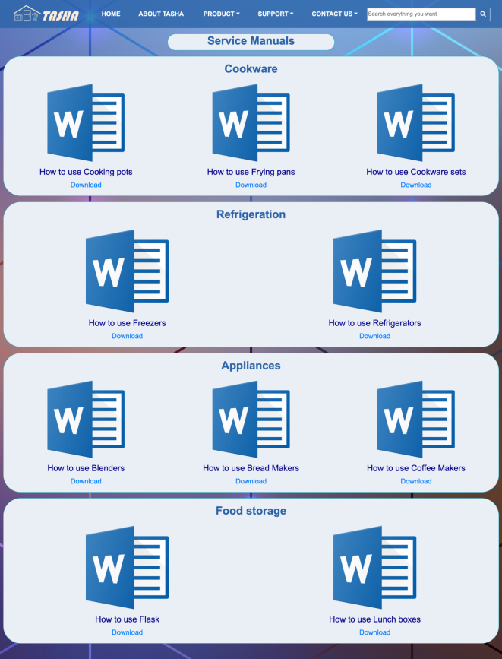

**XI/ About Tasha page:**

About Tasha company, mission and vision of Tasha.

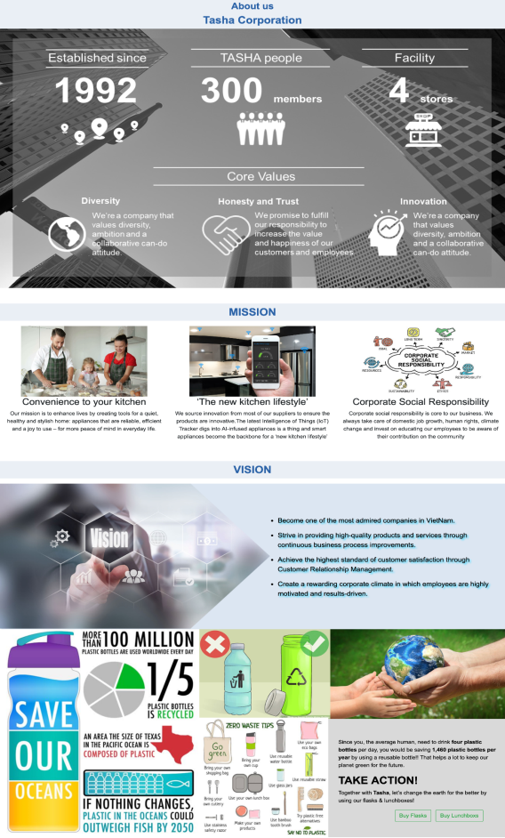

About our team

